Meadow Springs
Wedding Catering Menu

Your Catering Package at Meadow Springs includes much more than your meal. All dinner packages include complete table service consisting of:

Pressed Table Linens
Cloth Napkin
Table Runner
Chair Cover
Chair Sash
Plate Charger
Dinner and Dessert Plates
Stemmed Water Goblets
Choice of Tier One Centerpieces

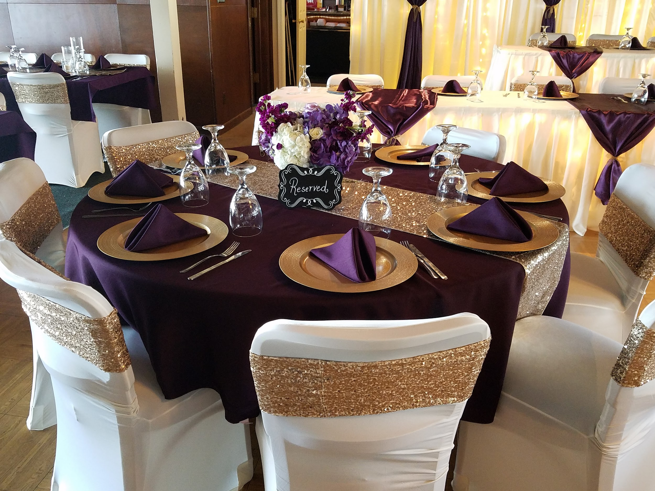

Whether you choose to have a plated meal, or serve your meal buffet style, Meadow Springs Staff will always be on hand to assist your guests.

Dinner Buffet #1
$24.75 per person
Choice of: One entree, One side item
& Two vegetables
Dinner roll w/ butter
Iced Tea & Lemonade

Prime Rib Buffet $30.75 per person

Dinner Buffet #2
$25.75 per person
Choice of: Two entrees, One side item
& Two vegetables
Dinner roll w/ butter
Iced Tea & Lemonade

Prime Rib Buffet $31.75

Plated Dinner #1
$26.75 per person
Choice of: One entree, One side item
& Two vegetables
Dinner roll w/butter
Iced Tea & Lemonade

Prime Rib Dinner $32.75 per person

Plated Dinner #2
$27.75 per person
Choice of: Two entrees, One side item
& Two vegetables
Dinner roll w/butter
Iced Tea & Lemonade

Prime Rib Dinner $33.75 per person

Entrees

Signature Parmesan Crusted Chicken
Tender chicken breast lightly breaded with our homemade bread crumbs
and parmesan cheese
Signature Roasted Pork Loin
Pork loin slow roasted for 5 hours in our signature seasonings
Teriyaki Chicken
Marinated chicken breast smothered in teriyaki sauce and pineapple
Hawaiian Ham
Sliced dinner ham glazed with brown sugar and pineapple
Baked Chicken
Tender, seasoned chicken breast in a light butter sauce
BBQ Pork Loin (Available sliced or shredded)
Our Signature Roast Pork Loin in a sweet & mild BBQ sauce

Premium Entrees
Add $1.00 per person

Monterey Chicken
Baked chicken breast smothered in BBQ and topped with bacon and Monterey jack cheese
Baked Steak
Baked cubed steak in savory brown gravy
Italian Beef
Thin sliced beef in Italian au jus with banana pepper rings
Roast Beef w/ Gravy
Thin sliced roast beef in savory brown gravy
Chicken Cordon Bleu
Tender baked chicken breast topped with thin sliced ham and swiss cheese
Chicken Parmesan
Our Signature Parmesan Crusted Chicken smothered in marinara sauce and mozzarella cheese
Chicken Marsala
Baked chicken breast smothered in creamy marsala sauce and mushrooms
Baked Salmon
Salmon baked in a lemon garlic sauce

Vegetarian Entrees
$25.75 per person

Pasta with Vegetables
Angel hair pasta sauteed with seasonal vegetables in garlic sauce
Eggplant Parmesan
Breaded eggplant topped with marinara sauce and mozzarella
Stuffed Portobello
Portobello cap stuffed with spinach, sun dried tomatoes and cream cheese

Sides

Loaded Mashed Potatoes
Creamy mashed potatoes with cheddar cheese, sour cream and bacon
Garlic Mashed Potatoes
Creamy mashed potatoes with garlic and parsley
Baked Potato
Classic baked potato served with butter and sour cream
Mashed Potatoes & Gravy
Creamy mashed potatoes with gravy (available with brown or poultry gravy)
Wild Rice Pilaf
Seasoned wild and white rice mix
Garlic Roasted Red Potato
Roasted chunks of red potatoes seasoned with garlic and spices

Premium Sides
Add $0.50 per person

Macaroni & Cheese
Classic creamy macaroni and cheddar cheese
Potatoes Au Gratin
Thinly sliced potatoes in a creamy cheddar cheese sauce
Baked Sweet Potato
Whole sweet potato baked and served with butter, brown sugar, and cinnamon
Twice Baked Potato
Baked potato stuffed with cheddar cheese, sour cream, and bacon
Ancient Grains Pilaf
Seasoned quinoa, couscous, rice and barley
Vegetables

Green Beans w/ Bacon
Green beans with real bacon pieces
Buttered Corn
Corn seasoned with butter, salt and pepper
Southwest Corn
Corn sauteed with red & green peppers
California Blend
Tender broccoli, cauliflower and carrots seasoned with salt and pepper
Green Beans w/ Sausage
Green beans with smoked sausage pieces
Steamed Broccoli
Tender broccoli florets seasoned with salt and pepper
Baked Beans
Baked beans in a sweet and tangy sauce
Peas
Tender peas seasoned with butter, salt and pepper

Premium Vegetables

Green Beans Almondine
Green beans smothered in a creamy mushroom sauce topped with toasted almonds
Glazed Carrots
Tender baby carrots coated with butter and honey
Green Bean Casserole
Green beans smothered in a creamy mushroom sauce and topped with crispy onions
Corn Casserole
Classic cornbread style casserole
Parmesan & Garlic Roasted Vegetables
Seasonal vegetables roasted with garlic and topped with parmesan cheese
Asparagus Spears
Roasted asparagus seasoned with lemon & garlic then topped with parmesan cheese

Salad
Add $1.50 per person

Garden Salad
Romaine & Iceberg mix topped with cherry tomatoes (Choice of 2 dressings)
Caesar Salad
Romaine lettuce with parmesan cheese, croutons and creamy caesar dressing
Olive Garden Salad
Romaine & Iceberg mix with slices of cucumber, black olives, cherry tomatoes and pepperoncini covered in italian dressing
Spinach Salad
Baby spinach topped with real bacon pieces, boiled egg, cherry tomatoes and mushrooms
Deluxe Pasta Salad
Tri-colored spiral pasta with cucumber, cherry tomato, black olives and italian dressing

Children’s Dinners
Ages 6 & under
$6.95 per person
(Children’s dinners also include vegetables served to other guests)

Entrees

Chicken Nuggets
Hot Dog
Mini Corn Dogs

Sides

Potato Chips
Applesauce
Mandarin Oranges

Appetizers
$80.95 per 100 pieces

Meatballs - BBQ, Sweet & Sour, or Swedish
Bourbon Smokies
Loaded Potato Rounds
Cheesy Bacon Ranch Bread
Wings (bone-in or boneless) - BBQ, Buffalo, Parmesan Garlic
Glazed Pineapple & Kielbasa
Pizza Bites
Taco Cups
Teriyaki Chicken Bites
Bacon Wrapped Smokies
Stuffed Mushrooms - Bacon & Cheese or Pepper & Onion
Spinach Artichoke Wontons
Shrimp Cocktail

Cold Appetizers

Fruit Kabobs
Caprese Bites
Ham & Pickle Rolls
Deviled Eggs
Finger Sandwiches: Chicken Salad, Ham Salad, Turkey, Ham, Roast Beef

